A000-Asia-BMAC-figurine, Bronze Age, 2000-1650 BCE-14 x 10 cm

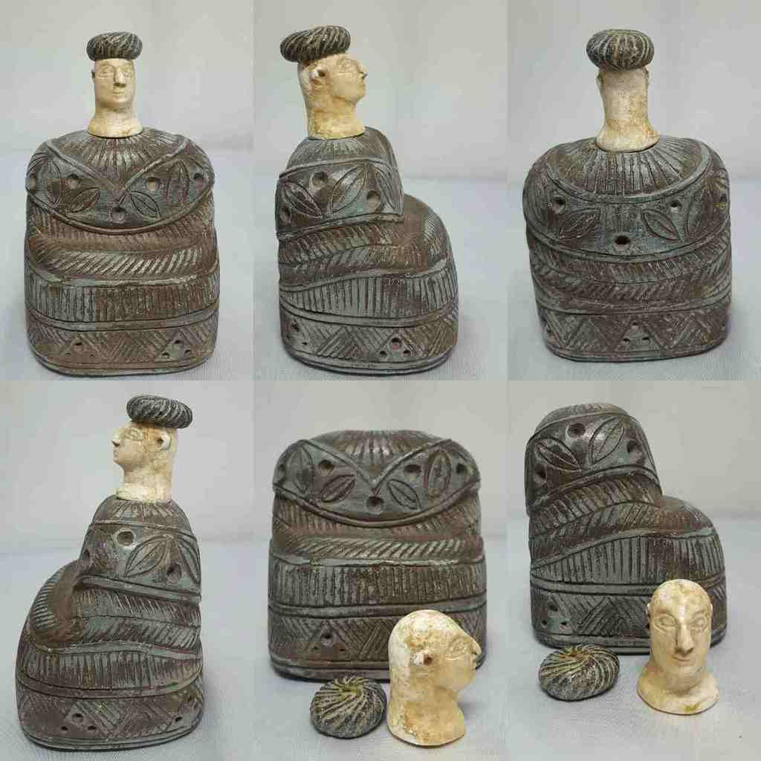

Fig. 1. BMAC-figurine, Bronze Age, 2000-1650 BCE-14 x 10 cm

Case no.: 2

Accession Number: A 156, AA162, A166 + A163 (cap), A1107

Formal Label: BMAC-figurine, Bronze Age, 2000-1650 BCE-14 x 10 cm

**Display Description**

This sculpture is from the Bronze Age Bactria-Margiana Archaeological Complex (BMAC), formerly the Oxus Civilization, of w Central Asia, ca 2300–1700 BCE. This sculpture depicts a seated female wrapped in a *kaunake* (the traditional Mesopotamian dress in the Bronze Age) which was originally composed of long stacked tuffs of sheepskin or goatskin, (sculpted here in dark green clinochlore, an aluminosilicate of iron and magnesium), the texture of which is rendered by a series of chevrons and vertical or diagonal parallel lines. Clinochlore is also used for her turban while her head is sculpted from white calcite.

These anthropomorphic female statuaries usually represented the pre-eminent goddess, who, in the mythology of w Central Asia, plays a regulatory role in the order of nature, controlling the wild forces symbolized by lions, serpents or dragons (Mattet and Amiet 2008: 282-283). This deity is also identifiable in glyptic (carving or engraving) sources, but its identity is more controversial in the statuary where it can also represent aristocratic ladies.

**LC Classification:** GN778.32.A4

Date or Time Horizon: Middle to Late Bronze Age, 2300–1700 BCE

Geographical Area: between Balkh, Afghanistan, and Merv, Turkmenistan

**Map, GPS coordinates:** Bactria (Balkh), Afghanistan,36.767791 66.900265; Merv [Erk Kala], Turkmenistan. 37.669606; 62.192567.

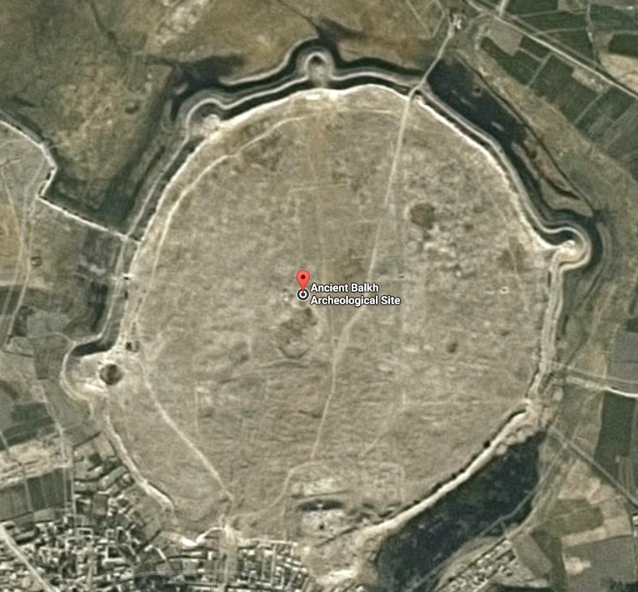

Fig. 1. Ancient Balkh, Bactria (Afghanistan), 36.767791 66.900265; Fig. 2. Map of Turkmenistan and Afghanishan. After Google.

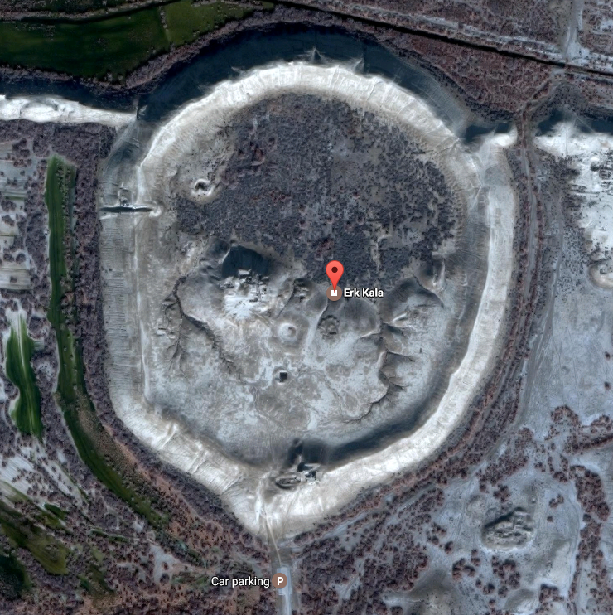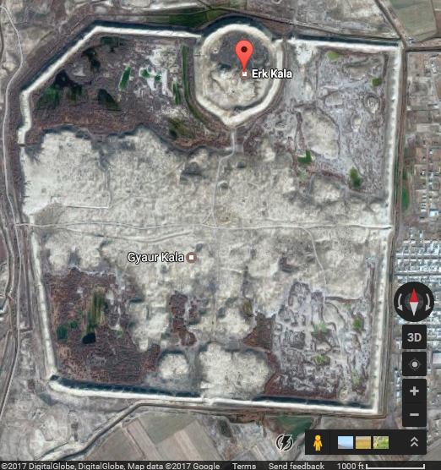

Fig. 3. Ancient Merv [Erk Kala], Turkmenistan. 37.669606; 62.192567, detail of interior area.

Fig. 4. Ancient Merv external ramparts. After Google.

Cultural Affiliation: Bactria-Margiana Archaeological Complex (BMAC), formerly Oxus Civilization

Media: composite; chlorite body and turban and white calcite head.

Dimensions: H 14 cm x W 10 cm

Weight:

Provenance: [vintage.intaglio](http://myworld.ebay.com/vintage.intaglio), Thailand

**Discussion:** Representational sculpture in w Central Asia in the Middle Bronze Age is rare. The highly stylized, sculpture above is a composite with green clinochlore for the body and turban and white calcite for the head. The nearest source of clinochlore for these BMAC sculptures is Khogyani District, Nangarhar Province, Afghanistan (4° N, 70° E, est.; MinDat, clinochlore).

Appendix: Individuals dressed in the *kaunake* in various contexts in order to interpret their rôle and significance in society.

**Example 1. Silver Pyxis in the Louvre Museum.**

 

Fig. 1. Silver Pyxis, AO 31881, Louvre Museum, acquired 2001. After <https://image.slidesharecdn.com/tosicambridgeshahdadfinal-140921080852-phpapp01/95/shahdad-shahri-sokhta-tepe-yahya-many-sites-for-a-single-history-91-638.jpg?cb=1411290523>

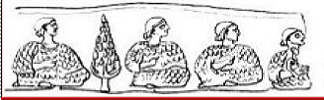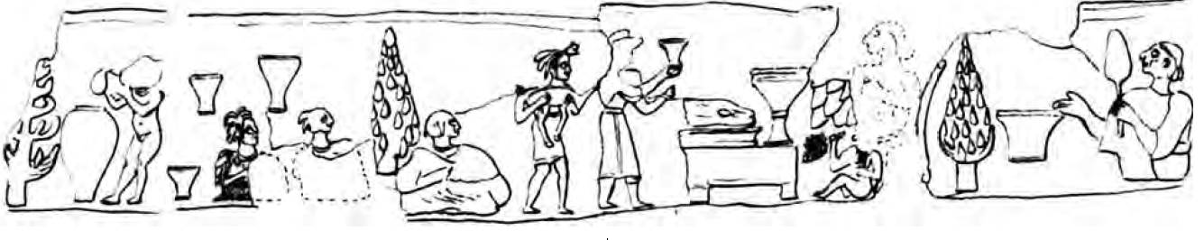

1 2 3 4 5 6 7 8 9 10 11 12 13 14 15 16 17 18 19 20 21 22

Glyptic scene on the Silver Pyxis in the Louvre Museum.

1. Seated woman with head covering, facing right, dressed in a *kaunake*, with right arm protruding
2. Fruit-bearing tree.
3. Same as 1.
4. Same as 1.
5. Same as 1.
6. Barren tree.
7. Amphora.
8. Naked servant dipping flagon in amphora.
9. Three flagons.
10. Seated woman with feather headdress, facing right, dressed in a *kaunake*, with right arm protruding
11. Same as 10.
12. Fruit-bearing tree.
13. Same as 1.
14. Servant with feather headdress carrying a sacrificial kid and following a priest.
15. Priest about to sprinkle consecrated libation on the slaughtered kid on the butcher block table.
16. Slaughtered kid on butcher block table.
17. Large flagon containing the sacrificial blood of the kid on butcher block table.
18. Servant offering grapes to slaughtered kid scene.
19. Deity looking on the sacrificial kid.
20. Fruit-bearing tree [signifying new life (?)].
21. Flagon with the sacrificial blood of the kid.
22. Deity holding a baton in the left hand and blessing the blood of the kid with right hand.

Example 2. Libation scene on silver vessel, Louvre Museum



Fig. 2. After <https://image.slidesharecdn.com/tosicambridgeshahdadfinal-140921080852-phpapp01/95/shahdad-shahri-sokhta-tepe-yahya-many-sites-for-a-single-history-94-638.jpg?cb=1411290523>

 

Fig. 3. Libation scene on silver vessel, Louvre Museum. After Amiet 1977, Fig. 13, pl 3. See also Hinz 1969, pl 5.

Silver cup with two registers. Bottom register: agricultural workers, three bearded men with kilts, two plowing one sowing seed, and two naked boys, one with two oxen, the other with two cattle plowing a field. Top register, three bearded men, seated, in three scenes. Scene one: Two men, one in a fleece wrap one in a textile wrap, talking and gesticulating with one arm held up to the other, one man making an account on a table. Scene two: two men one in a fleece wrap one in a textile wrap, looking to the right. Scene three: three bearded men, one with fleece wrap holding a sheaf (of accounts?), two men in textile wraps, between them two flagons above a basket of fruit, one gesticulating with one arm held up to the other and the other drinking from a goblet.

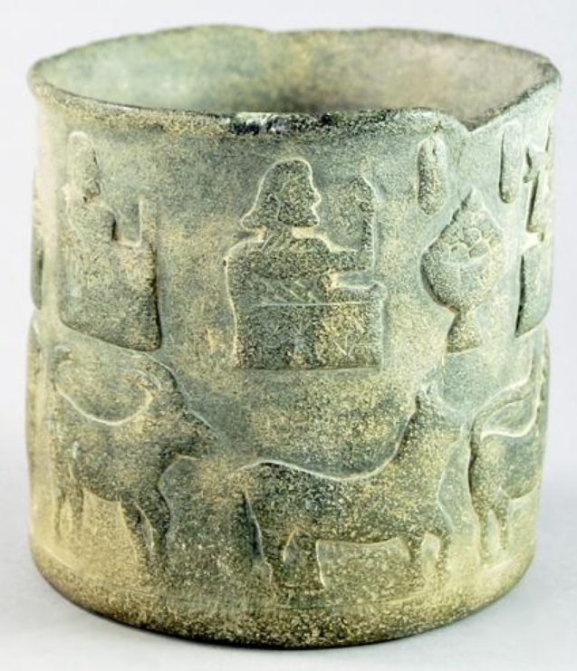

### Fig. 4. This clinochlore vessel shows a register of seated individuals with stylized fleece wrappers above a band of domesticated (?) sheep and cattle. From Roseberys 70/76 Knights Hill London SE27 0JD United Kingdom, Lot 1349 of 1116, Sept. 2014. 13cm high. After <https://auctions.roseberys.co.uk/images/lot/1654/16548_8.jpg>

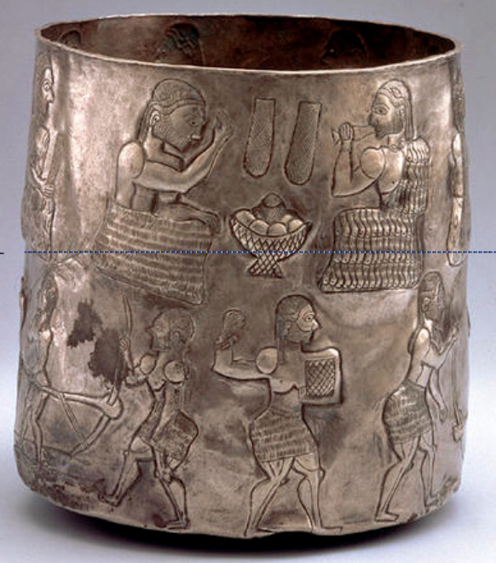

Fig. 5. Bactrian Silver Cylindrical Cup **Late 3rd-early 2nd millennium BCE (H 12.6 cm)** with Agricultural and Ceremonial Scene after https://encrypted-tbn1.gstatic.com

## 

A fine metalworking tradition appears to have developed in western Central Asia in the late third to the early second millennium B.C. Based on comparisons with excavated pottery types and with finds in the so-called Fullol hoard of objects from northern Afghanistan,1 a number of gold and silver vessels have been attributed to Bronze Age Bactria. Perhaps the most exceptional are cylindrical silver vessels with elaborate figural scenes executed in low relief with incised details, all of which may come from a single workshop.

## 

On this example, two bearded and moustached male banqueters wearing fillets in their bound long hair are seated in a row above men and boys plowing a field. The main personage in this upper row, who faces left, is distinguished by an elliptically shaped bead on his fillet; he also wears a necklace and bracelet with similar beads, all bearing hatched patterns that might suggest veined stone such as agate. A robe with very clearly rendered individual tufts covers one arm entirely and envelops the rectangular form of his lower body. The man's exposed right arm is raised to hold a tall footed beaker to his mouth (this is the only figure to have a defined mouth). In front of him are a footed fruit bowl, a pair of tall vessels, and a second seated figure wearing a robe with a herringbone pattern. The proper right arm of this figure is raised toward the main personage. Also part of this banqueting scene are five other seated male figures, their garments distinguished alternatively by individual tufts or horizontal rows of hatchings that form herringbone patterns. Some figures hold beakers and one rests a hand on a large altar-like rectangular object with a crosshatched pattern.

## 

In the scene below, two plows are held by long-haired men wearing short kilts with herringbone patterns. Before them, nude youths holding branches attempt to keep two pairs of oxen under control. Another male figure holds a square object-perhaps a box or even a drum-under one arm, and raises the other one. The figures stand on freshly seeded earth; between the animals is an object with a wavy-line pattern and seed-like elements along the top edge. Although difficult to interpret, this could indicate landscape in viewed from above or a vessel in profile.

## 

While iconographic elements such as the garments connect the imagery on this cup to the art of Mesopotamia and Elam, certain aspects of style are very distinctive. In particular, a strong interest in the placement of human and animal figures in space is manifest. The oxen in the background are darkened with hatched lines to clearly distinguish them from those in the foreground.3 The muscular shoulders of the human figures may be depicted in profile or in three-quarter view, and they may have one rather than two nipples showing. The two plows, one seen from the front and the other from the back, are placed behind one and in front of the other nude youth. An interest in the use of patterning to define the textures of garments and objects is also evident.

## 

In style, this cup is closely related to a silver vessel in the Levy-White collection.4 The main personage in a hunting scene there bears a close resemblance to the main figure on the present cup. He is bearded, with a well-delineated mouth, and has elliptical beads both in his hair and around his neck. A figure with similar features appears on another cup, which depicts the aftermath of a successful hunt.5

1. Amiet 1988b, pp. 136, 161, describes this hoard (like the "Astrabad treasure" from Iran with related material) as a contrived collection of objects from clandestine excavations in northern Afghanistan; see Tosi and Wardak 1972, pp. 9-17.

2. See Amiet 1986, pp. 328-29, fig. 202; Pottier 1984, pp. 73, 212, pl. xxx, fig. 250; Deshayes 1977, pp. l04-5; Amiet 1988b, p. 136, fig. 9.

3. This convention is also used on a cylindrical cup in the Louvre, with a chariot scene: see Amiet 1988b, p. 163, fig. 6.

4. See Pittman 1990, pp. 43-44, no. 30.

5. Amiet 1986, pp. 326-27, fig. 201.

## Text and image from the website of the Miho Museum.



Fig. 6. Togolok 21

Togolok-1, Togolok-21, and Gonur employed fire worship and libation rituals, which involved something like the haoma drink as part of a common Indo-Iranian heritage and not specific to Zoroastrianism (Dandamaev 1989: 170; on fire and haoma in Indo-Iranian religion, see also Frye 1996: 68; Gnoli 2006: 97). As Victor Sariniandi has stated. “If Togolok was a temple connected with cultic libations and a fire cult, we can assume a connection with the milieu from which Zoroatrianism might have sprung. However, these elements so important in Zoroastrianism do not permit us to view this structure as a true Zoroastrian temple, for nowhere in the Avesta is there a mention of temples. The observance of cultic rituals in temples seems to have been a feature of the religious life of the inhabitants of both Margiana and Bactria, who were largely related and shared a similar culture and religious beliefs (Sariniandi The use of the term "proto-Zoroas trian" came under especial fire, since we do not know exactly when and where the great prophet of the ancient Iranian religion lived.4 However, J. Choksy has recently expressed a very positivist opinion that the ritual room at Togolok-21 may have been "a pre-Zoroastrian or even a very early Zoroastrian" fire temple (Choksy 2007: 261).

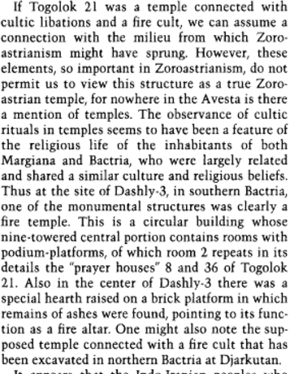**one image of a seated female wrapped in a garment with attached wool clumps is a specifically western Central Asian figural type. The body is made of chlorite, while the regularly formed face and neck are carved from contrasting white limestone and the light black hair and rest of the head is carved from bitumen. A fragment of a similar sculpture has been recently excavated from the Margiana region, site of the flourishing Nanazga culture. It is thought that this region was also heavily influenced by the Elamite culture, and we can see fragments of pottery with proto-Elamite script inscriptions from Gonur Tepe and silver pin with designs of seated women.**

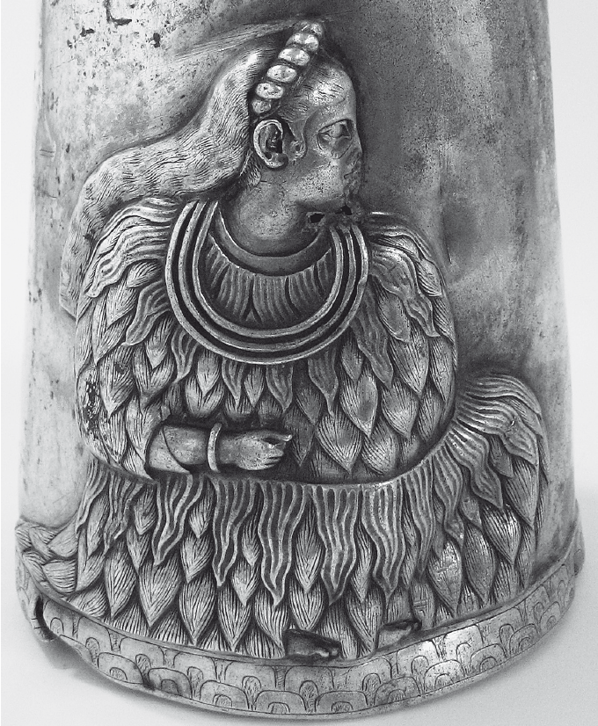

Fig. 7. From <https://s-media-cache-ak0.pinimg.com/236x/e3/fd/d2/e3fdd212a99007ac7d3c3c948b75fe89.jpg>



**This image of a repoussé female on a silver vase is thought to come from Persepolis and to be an Elamite work from the end of the 3rd millennium. The silver vase is also inscribed with a proto-Elamite script, the text of which lists the name of Narunde, the sister goddess of the god of war and fertility Kiririsa, and it is possible that the present sculpture is an image of a goddess from this earth mother goddess lineage.**

**References:**

Amiet, Pierre. 1977. “Bactriane proto-historique,” *Syria* 54: 89-121.

Amiet, Pierre. 1978. “Antiquités de Bactriane,” *Révue du Louvre* 28: 153-164.

Hinz. Walther. 1969. “Eine neu gefundene Altelamische Silbervase,” In *Altiranische Funde und Forschungen*. Berlin: Walter de Gruyter, pp. 11-44.

Mattet, Laurence and Pierre Amiet. 2008. [*Le profane et le divin: arts de l'antiquité, de l'Europe au sud-est asiatique : fleurons du musée Barbier-Mueller*](http://www.worldcat.org/title/profane-et-le-divin-arts-de-lantiquite-de-leurope-au-sud-est-asiatique-fleurons-du-musee-barbier-mueller/oclc/298112421&referer=brief_results). Paris: Hazan; Genève: Musée Barbier-Mueller.

MinDat (clinochlore). https://www.mindat.org/loc-188777.html).

# Pittman, Holly. 1984. ***Art of the Bronze Age: Southeastern Iran, Western Central Asia and the Indus Valley.* New York: Metropolitan Museum of Art.**

Potts, Daniel. 2008. “Puzur-Inšušinak and the Oxus Civilization (BMAC): Reflections on Šimaški and the geo-political landscape of Iran and Central Asia in the Ur III period,” *Zeitschrift für Assyriologie und vorderasiatische Archäologie*, 98(2): 165–194.

Sariniandi, Victor I. 1990. “Togolok 21, an Indo-Iranian Temple in the Karakum,” *Bulletin of the Asia Institute*, New Series, 4 (In honor of Richard Nelson Frye: Aspects of Iranian Culture): 159-165.